If our brain decides before we are aware, should we change the law.

A Continue as it
B Fundamentally change
C Only change in specific context

Soft law guidelines system?

If we dun have freewill < -- > punishment
Potential time prior we are aware of doing sth, impulsive thoughts, consciousness

https://pmc.ncbi.nlm.nih.gov/articles/PMC4371735/ (The Utility of Neuroimaging Studies for Informing Educational Practice and Policy in Reading Disorders)

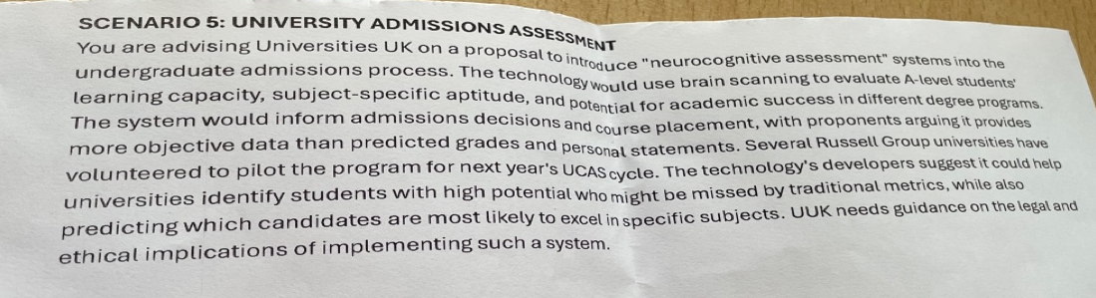

Legal: Lack of regulations to rule how the results can be used.
result x = what the students want to study how should the uni consider the results? if the result not the one that the students want to study how will the uni balance the result and the intention of the students?

Legal: Involuntary issues how to collect consent

Ethnical: Their brain maybe still developing fairness?

